Quotation
Quotation Date: | 20/06/23
Quotation No: | 2
Completed By: | Gwbuilders

Quantity | Item |  | Amount
 | 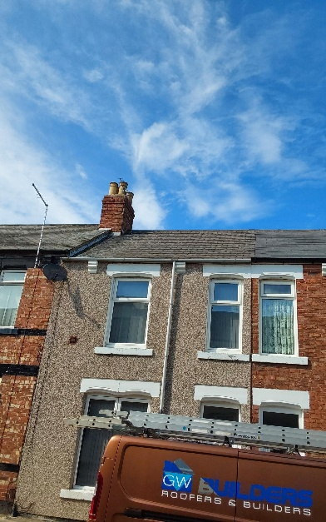  Stack repoint and reflornch step flashing repoint |  | £300
 | Repoint ridges main and off shot |  | £250
 | 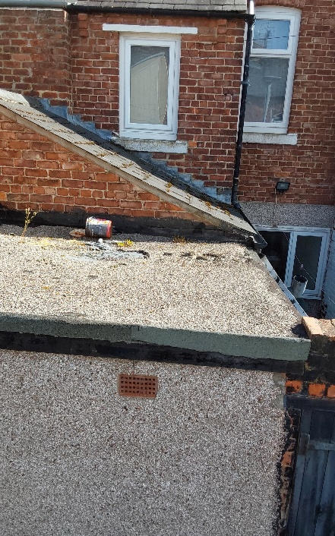  New flat roof out back |  | £650
 | 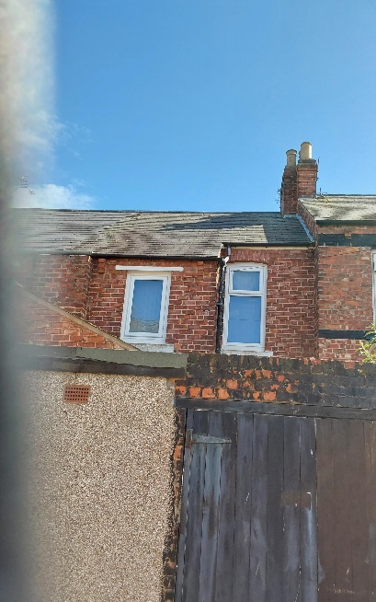  Gutter clean |  | £100
 | 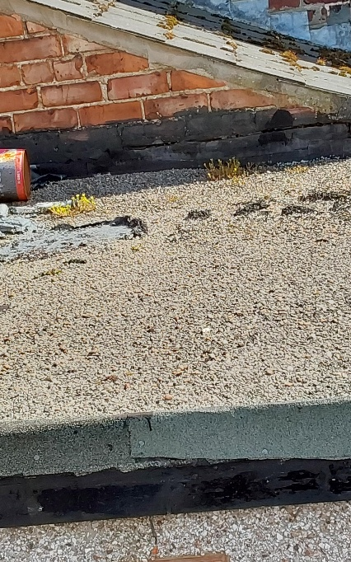 |  | £200
 |  | Sub Total:
 |  | VAT:
 |  | Total: | £1500
Acceptance: To accept this quotation in writing, please send an email to office@gwbuilders.co.uk as proof of acceptance. Alternatively, please return a signed copy of this quotation to a member of our team.
Date Accepted: | _________________________ | Name: | __________________________
 |  | Signature: | __________________________

