Quotation
Quotation Date: | 19/06/23
Quotation No: | 6
Completed By: | Gwbuilders

Quantity | Item |  | Amount
 | 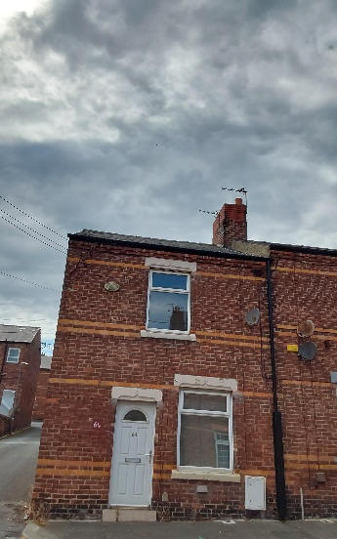  Stack repoint and reflornch step flashing point |  | £300
 | 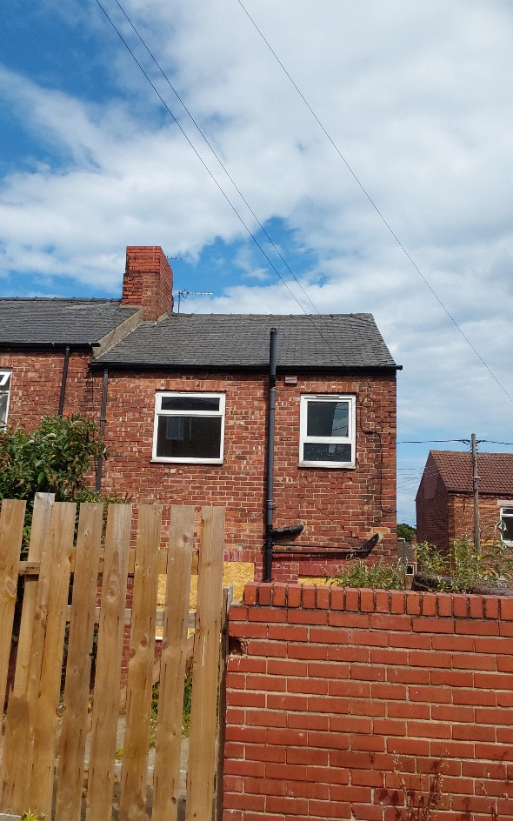  Repoint ridges |  | £150
 | Slates out front and back |  | £200
 | Gutter clean |  | £120
 |  | Sub Total:
 |  | VAT:
 |  | Total: | £770
Acceptance: To accept this quotation in writing, please send an email to office@gwbuilders.co.uk as proof of acceptance. Alternatively, please return a signed copy of this quotation to a member of our team.
Date Accepted: | _________________________ | Name: | __________________________
 |  | Signature: | __________________________

